**NAME:V.RAMYA SRI**

**REG.NO: 192124039**

**COURSE CODE: ITA0448**

**ASSIGNMENT DAY 5**

**1. i) Describe how histogram charts are created in R. Create a histogram chart for the**

**below given age attribute.**

**Age : 5,45,23,30,33,32,34,35,42,41,28,29**

**ii) Create a 3D Pie Chart for the dataset “political Knowledge” with suitable**

**labels and colour.**

**CODE**:

1)i)age <- c(5, 45, 23, 30, 33, 32, 34, 35, 42, 41, 28, 29)

hist(age, main = "Age Distribution", xlab = "Age", ylab = "Frequency")

ii)library(plotrix)

political_knowledge <- c("Low", "Low", "Medium", "Medium", "High", "High", "High")

pie3D(table(political_knowledge), main = "Political Knowledge",

col = c("red", "orange", "green"), explode = 0.1)

**2. Write R code for the below output Figure 1 shows Bike is assigned red , car is**

**assigned yellow , bus is assigned blue , auto is assigned black , and train is assigned**

**white. Mention the parameters used in the below barchart.**

**CODE:**

# Load the mtcars dataset

data(mtcars)

# Create a boxplot graph of mpg by cyl

boxplot(mpg ~ cyl, data = mtcars, xlab = "Number of Cylinders", ylab = "Miles per Gallon",

main = "Relationship between MPG and Cylinders")

# Define a recursive function to find the sum of n natural numbers

sum_natural <- function(n) {

if (n == 0) { # Base case: sum of 0 numbers is 0

return(0)

} else { # Recursive case: sum of n numbers is n + sum of (n-1) numbers

return(n + sum_natural(n-1))

}

}

# Test the function with n = 10

sum_natural(10) # Output: 55

**3. Create a Boxplot graph for the relation between &quot;mpg&quot;(miles per galloon) and**

**&quot;cyl(number of Cylinders) for the dataset &quot;mtcars&quot; available in R Environment.**

**v)Write R program to find the sum of Natural Numbers using Recursion**

**CODE:**

# Load the mtcars dataset

data(mtcars)

# Create a boxplot graph of mpg by cyl

boxplot(mpg ~ cyl, data = mtcars, xlab = "Number of Cylinders", ylab = "Miles per Gallon",

main = "Relationship between MPG and Cylinders")

# Define a recursive function to find the sum of n natural numbers

sum_natural <- function(n) {

if (n == 0) { # Base case: sum of 0 numbers is 0

return(0)

} else { # Recursive case: sum of n numbers is n + sum of (n-1) numbers

return(n + sum_natural(n-1))

}

}

# Test the function with n = 10

sum_natural(10) # Output: 55

**4. a. Melt ‘airquality’ data set which inbuild dataset in ‘R’ and display as a long – format**

**data?**

**b. Melt air quality data and specify month and day to be “ID variables”?**

**c. Cast the molten ‘airquality’ data set.**

**d. Use cast function appropriately and compute the average of Ozone, Solar, Wind**

**and temperature per month?**

**e. Create a boxplot for ozone reading of ‘airquality’ dataset. Add title, label and color.**

**CODE:**

4)a)library(reshape2)

data(mtcars)

airquality_melt <- melt(airquality)

b)airquality_melt <- melt(airquality, id.vars = c("Month", "Day"))

head(airquality_melt)

c)airquality_cast <- dcast(airquality_melt, Month ~ variable)

head(airquality_cast)

d)library(plyr)

airquality_avg <- cast(airquality_melt, Month ~ variable, mean)

head(airquality_avg)

e)library(ggplot2)

ggplot(data = airquality, aes(x = "", y = Ozone)) +

geom_boxplot(fill = "lightblue", color = "blue") +

labs(title = "Boxplot of Ozone Readings", y = "Ozone Reading")

head(airquality_melt)

**5. a. Write a program for creating a pie-chart in R using the input vector (21,62,10,53).**

**Provide labels for the chart as ‘London’, ‘New York’, ‘Singapore’, ‘Mumbai’. Add a**

**title to the chart as ‘city pie-chart’ and add a legend at the top right corner of the chart.**

**b. Using linear regression analysis establish a relationship between height and weight**

**of a person using the input vector given below.**

**# Values of height**

**151, 174, 138, 186, 128, 136, 179, 163, 152, 131**

**# Values of weight.**

**63, 81, 56, 91, 47, 57, 76, 72, 62, 48 Predict the weight of a person with height 170.**

**c. Visualize the regression graphically.**

**d. Call ‘mtcars’ which is built in dataset in ‘R’ and plot distribution of mpg feature.**

**Make x axis range from 10 to 35 and plot title as “More trends in 70’s Vehicles”.**

**e. Find statistical summary of the ‘mtcars’ dataset.**

**CODE:**

# Input vector

> # Input vector

> input_vector <- c(21, 62, 10, 53)

> # Labels for chart

> labels <- c("London", "New York", "Singapore", "Mumbai")

> # Create pie chart

> pie(input_vector, labels = labels, main = "City Pie Chart")

> # Add legend

> legend("topright", legend = labels, fill = rainbow(length(labels)))

> # Input vectors

> height <- c(151, 174, 138, 186, 128, 136, 179, 163, 152, 131)

> weight <- c(63, 81, 56, 91, 47, 57, 76, 72, 62, 48)

> # Perform linear regression

> fit <- lm(weight ~ height)

> # Predict weight for height 170

> predict(fit, data.frame(height = 170))

1

76.22869

> # Create scatter plot

> plot(height, weight, main = "Height vs Weight")

> # Add regression line

> abline(fit, col = "red")

> # Set x-axis range

> x_range <- c(10, 35)

> # Create histogram

> hist(mtcars$mpg, xlim = x_range, main = "More Trends in 70's Vehicles", xlab = "MPG")

> e)summary(mtcars)

**6. There is a popular built-in data set in R called &quot;mtcars&quot; (Motor Trend Car Road Tests),**

**which is retrieved from the 1974 Motor Trend US Magazine.**

**(i)Find the dimension of the data set &amp; Give the statistical summary of the features.**

**(ii)Create correlation matrix between mpg vs all other features and print the high 3**

**correlated Features(both +ve and -ve)**

**(iii)Plot the Box plot for “mpg” group by “cyl” feature.**

**(iv)Create a scatter plot graph for the relation between &quot;mpg&quot;(miles per gallon) and**

**&quot;hp&quot;(horse power) group by cyl(number ofcylinder)**

**Sample Output:**

**(v) Generate a multiple regression model to establish the relationship between &quot;mpg&quot;**

**as a response variable with &quot;disp&quot;,&quot;hp&quot; and &quot;wt&quot; as predictor variables. Plot the**

**regression line. Find the MSE of the model.**

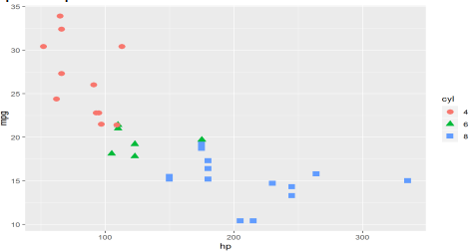

**CODE:**

data(mtcars)

> # Dimensions of the data set

> dim(mtcars)

[1] 32 11

> # Statistical summary of the features

> summary(mtcars)

mpg cyl disp hp drat

Min. :10.40 Min. :4.000 Min. : 71.1 Min. : 52.0 Min. :2.760

1st Qu.:15.43 1st Qu.:4.000 1st Qu.:120.8 1st Qu.: 96.5 1st Qu.:3.080

Median :19.20 Median :6.000 Median :196.3 Median :123.0 Median :3.695

Mean :20.09 Mean :6.188 Mean :230.7 Mean :146.7 Mean :3.597

3rd Qu.:22.80 3rd Qu.:8.000 3rd Qu.:326.0 3rd Qu.:180.0 3rd Qu.:3.920

Max. :33.90 Max. :8.000 Max. :472.0 Max. :335.0 Max. :4.930

wt qsec vs am gear

Min. :1.513 Min. :14.50 Min. :0.0000 Min. :0.0000 Min. :3.000

1st Qu.:2.581 1st Qu.:16.89 1st Qu.:0.0000 1st Qu.:0.0000 1st Qu.:3.000

Median :3.325 Median :17.71 Median :0.0000 Median :0.0000 Median :4.000

Mean :3.217 Mean :17.85 Mean :0.4375 Mean :0.4062 Mean :3.688

3rd Qu.:3.610 3rd Qu.:18.90 3rd Qu.:1.0000 3rd Qu.:1.0000 3rd Qu.:4.000

Max. :5.424 Max. :22.90 Max. :1.0000 Max. :1.0000 Max. :5.000

carb

Min. :1.000

1st Qu.:2.000

Median :2.000

Mean :2.812

3rd Qu.:4.000

Max. :8.000

> # Correlation matrix between mpg and other features

> correlations <- cor(mtcars)

> # Sort the correlations by the absolute values

> correlations_sorted <- sort(abs(correlations[,'mpg']), decreasing = TRUE)

> # Print the top three highest correlated features

> correlations_sorted[1:3]

mpg wt cyl

1.0000000 0.8676594 0.8521620

**7. (i) Use melt and cast function to find mean of numeric data in dataset based on**

**Species group.**

**(ii) Generate a suitable plot which summaries statistical parameter of Sepal.Width**

**based on Species group**

**(iii) Generate scatter plot between Sepal.Length vs Sepal.Width grouped by Specias.**

**Sample Output:**

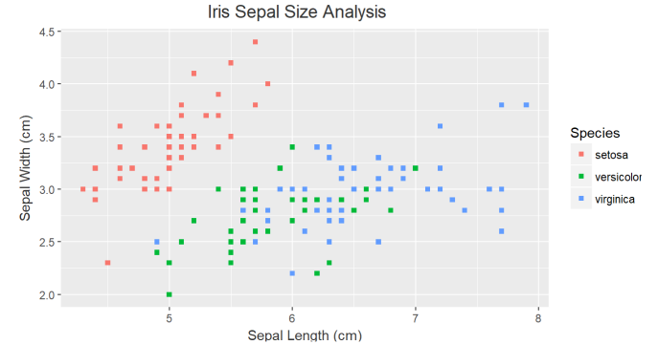

**CODE:**  
7)a)# Load the reshape2 package

library(reshape2)

# Melt the iris data set

melted_iris <- melt(iris, id.vars = 'Species')

# Cast the molten data set to find the mean of the numeric variables based on the species group

mean_iris <- dcast(melted_iris, Species ~ variable, mean)

# View the mean_iris data frame

mean_iris

b)# Load the ggplot2 package

library(ggplot2)

# Create a box plot of Sepal.Width grouped by Species

ggplot(iris, aes(x = Species, y = Sepal.Width)) +

geom_boxplot() +

ggtitle("Box plot of Sepal.Width by Species")

c)# Create a scatter plot of Sepal.Length vs Sepal.Width grouped by Species

ggplot(iris, aes(x = Sepal.Length, y = Sepal.Width, color = Species)) +

geom_point() +

ggtitle("Scatter plot of Sepal.Length vs Sepal.Width by Species")

**8. A) Heights(in cm) of father and son are given as follows**

**Father(X): 150 152 155 157 160 161 164 165**

**Son (Y) : 154 156 158 159 160 162 161 164**

**Fit a regression line parameters to predict the height of son given the height of father.**

**Write R code for same.**

**B) Fit a regression line parameters distribution with the following data**

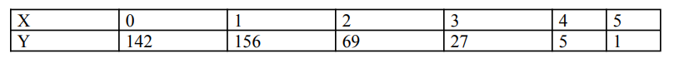

**CODE:**

# Heights of father and son

father_height <- c(150, 152, 155, 157, 160, 161, 164, 165)

son_height <- c(154, 156, 158, 159, 160, 162, 161, 164)

# Fit a regression line to predict the height of son given the height of father

regression_model <- lm(son_height ~ father_height)

# Print the summary of the regression model

summary(regression_model)

B)# Fit a regression line to the data

regression_model <- lm(y ~ x, data = data_df)

# Print the summary of the regression model

summary(regression_model)